

Mateusz Zaboklicki 40212780 | Advanced Web Technologies | November 2, 2016

My Movie Collection

**Python Application Report**

Contents

1. Overview 2

Users Implications 3

Design implications: 3

Resources: 4

2. Software Design 4

3. Evaluation of the application 5

3.1 Unforeseen Events. 5

3.2 Weak and Strong Points of the project. 5

4. Screenshots 5

6

5. References 10

6. Resources 11

# Overview

I have been asked by Dr. Simon Wells to create online application that should be designed with Python software and running in Levinux environment. The application should be also available to access through Putty. The application can also include other languages like HTML, CSS or JavaScript but mainly should use Python programing.

I decided to develop the application that will be easy to use for all the users and will be easy to interact and navigate. I decided that my target audience will be between 16 – 40 years old. My application was designed for learning and training purposes and I would like to develop it bit better when I’m going to feel more comfortable with using Python programing. The most recent version of my application is available to access through my GitHub account: <https://github.com/mati87118/MZMovie_Collection>

“My Movie Collection” is an online application that allow users to view my movie collection grouper by four categories. The application also contains few extra pages with some basic information about the movie collection. Users are also able to enter the database page where I decided to store all four categories of movies along with their titles, category, director, media type, date of the release and finally picture of each movie. The second database that I decided to include in my application is on single page where information from first database are stored along with the second database that stores title and names of five main actors from the movie. Both databases are presented as a table. I decided to use JSON for both databases because it is easy to use and is also user friendly.

The purpose of application that I developed was to present the collection of my favorite movies and to present my programing skills and the knowledge that I gained during working through tutorials and workbook.

### Users Implications

During the time that users will use my application there are some tasks that they can perform like:

* Read information about my movie collection that can be accessed on the “Home” and “About” page.
* Read the information about the movies and their short descriptions.
* View the pictures of each movie on appropriate page.
* Access the information about main five actors that were in each movie and director of each of them.
* Users can access my online application using most popular internet browsers at the localhost address <http://localhost:5000>
* User will be redirected to the IMD.com page where there accesses the direct information about three movies from index page.

### Design implications:

* Consistent navigation – Navigation will be easy to use and will be consistent through the all pages of my application. Navigation will be placed on the top of the page too provide professional look and to avoid any confusion.
* Content - that will be used in my application will be clear and easy to access.
* Fonts – that will be used in the application will be user friendly, easy to read and visually attractive.
* Color scheme and layout – both stay consistent across whole application to provide as professional look as possible and to be suitable and attractive for users.

### Resources:

During the time that I was developing my online application and to complete the project successfully I was using mostly module workbook that was provided by Dr. Simon Wells and some of the necessary notes that can be accessed on module website. I was also using knowledge and of the students that were helping us during the practical sessions in JKCC. On the top of that I accessed huge range of various pages like Stack Overflow that was helpful and documentation that was provided Python official website.

All the images that were used in my applications were founded and downloaded from Google. In the reference section I will provided the appropriate pages that they were downloaded from.

# Software Design

Application development stage appeared to be the most challenging part of this project because I never worked with Python before so, the lack of experience was the biggest problem however I took some of the steps that helped me to get some basic knowledge about Python. First, I was working through workbook that was provided by Dr. Simon Wells and through the tutorials that were available on module website and they helped me a lot because in the workbook I found many helpful information. I also spent many hours on watching tutorials on YouTube were very experienced users where guiding me through the necessary tutorials. I also founded website Lynda.com very helpful and because I was using it previously in college I founded few helpful tutorials there.

I decided to start building my application by installing all necessary software and environment that I wanted my application to run on. I also decided to use Bootstrap templates that were provided by Dr. Simon Wells and were available on module website. It seems to be the best and the easiest option for my application to run smoothly which saved me from confusion and frustration that appeared while I was working on my last project. I then followed all the steps that were described in the module workbook to successful customizing my application.

The main problem that appeared while I was working on my application was message printed in Putty and it was called very humoristic “broken pipe” and because of that it was necessary to restart the application repeatedly. I cannot describe the words and sentences that I was shouting at my laptop during the time that message appeared. I was cursing the developers of that software and I was hoping that someday their pipe will break.

# Evaluation of the application

If I had a chance to work in the future on the similar project I would add some more functionality. I would add registration form that would allow me to store some information about users in the database. On the top of that I would implement logins for different types of users which would add more functionality to the final applicati0n. I would like to also add admin panel where user would be able to edit database. I would also definitely take more time while working on HTML to add professional look of the application and to make it be more user friendly.

The biggest problem while I was working on my application was lack of previous experience which caused a frustration and confusion on the beginning of the project. However, the longer I was working on my application and more research I carried I started to feel more confident. At the end of my project I can say that I am proud from the final application and the fact that I learnt a lot about Python programing.

### 3.1 Unforeseen Events.

During the time that I was working on my project unforeseen event appeared an because of that I haven’t that much time that I was expecting. The problem was the health issues of my wife that was waiting for IVF treatment and during that times she was taking chromones which caused a lot problems and many times I had no other option but either go with my wife to the hospital or stay at home and look over her.

### 3.2 Weak and Strong Points of the project.

The areas that I would recommend to improve in the future should be planning stage of my project which was a week point of it. In the future, I should concentrate more to prepare plan and keep on the track all the time.

Time management is another weak point and the area where I should improve in the future. I haven’t thought that additional research will take so long and because of that I haven’t that much time to work on my paperwork.

Strong point of the project was the access to all necessary resources like Python, Putty, VIM, WIN SCP and Microsoft Word which were very helpful. The workbook provided by Dr. Simon Wells were also a strong point of the project because it allowed me to successfully complete my project.

# Screenshots

Home Page

# 

About Page

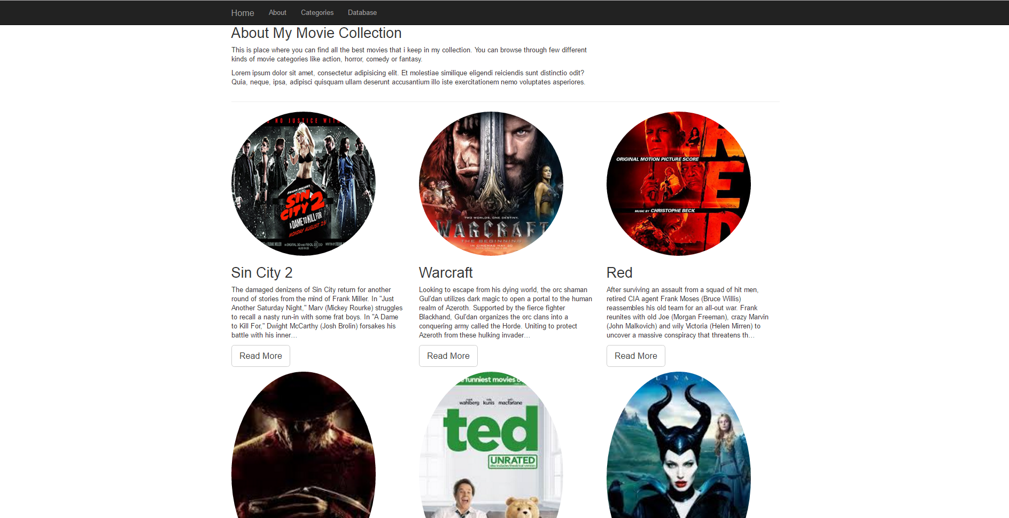

Categories Page

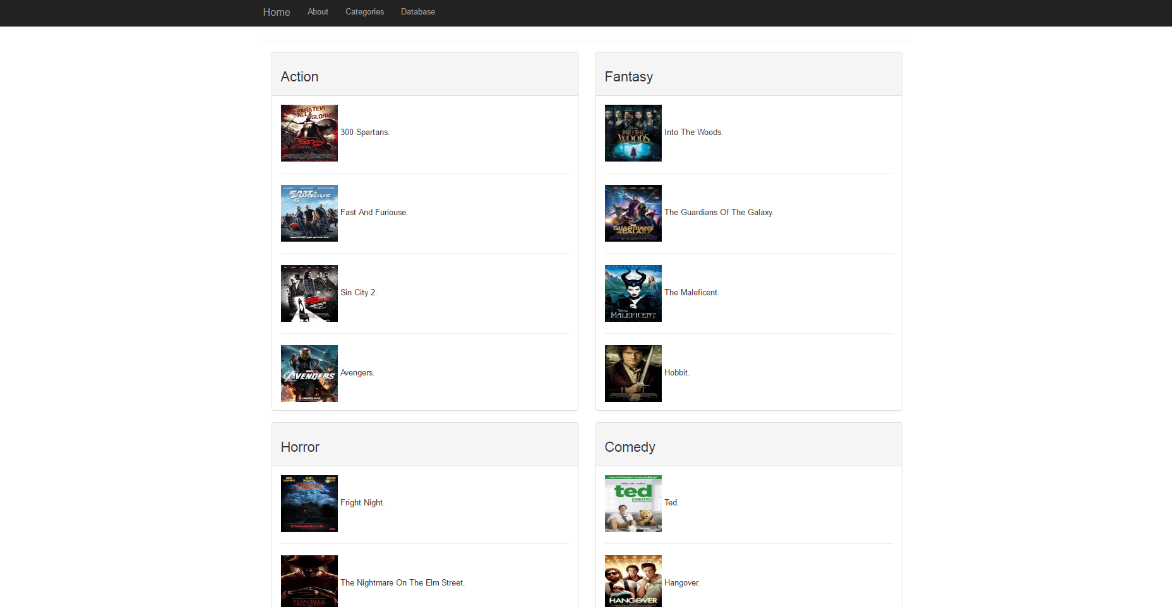

Database Page with All Movies

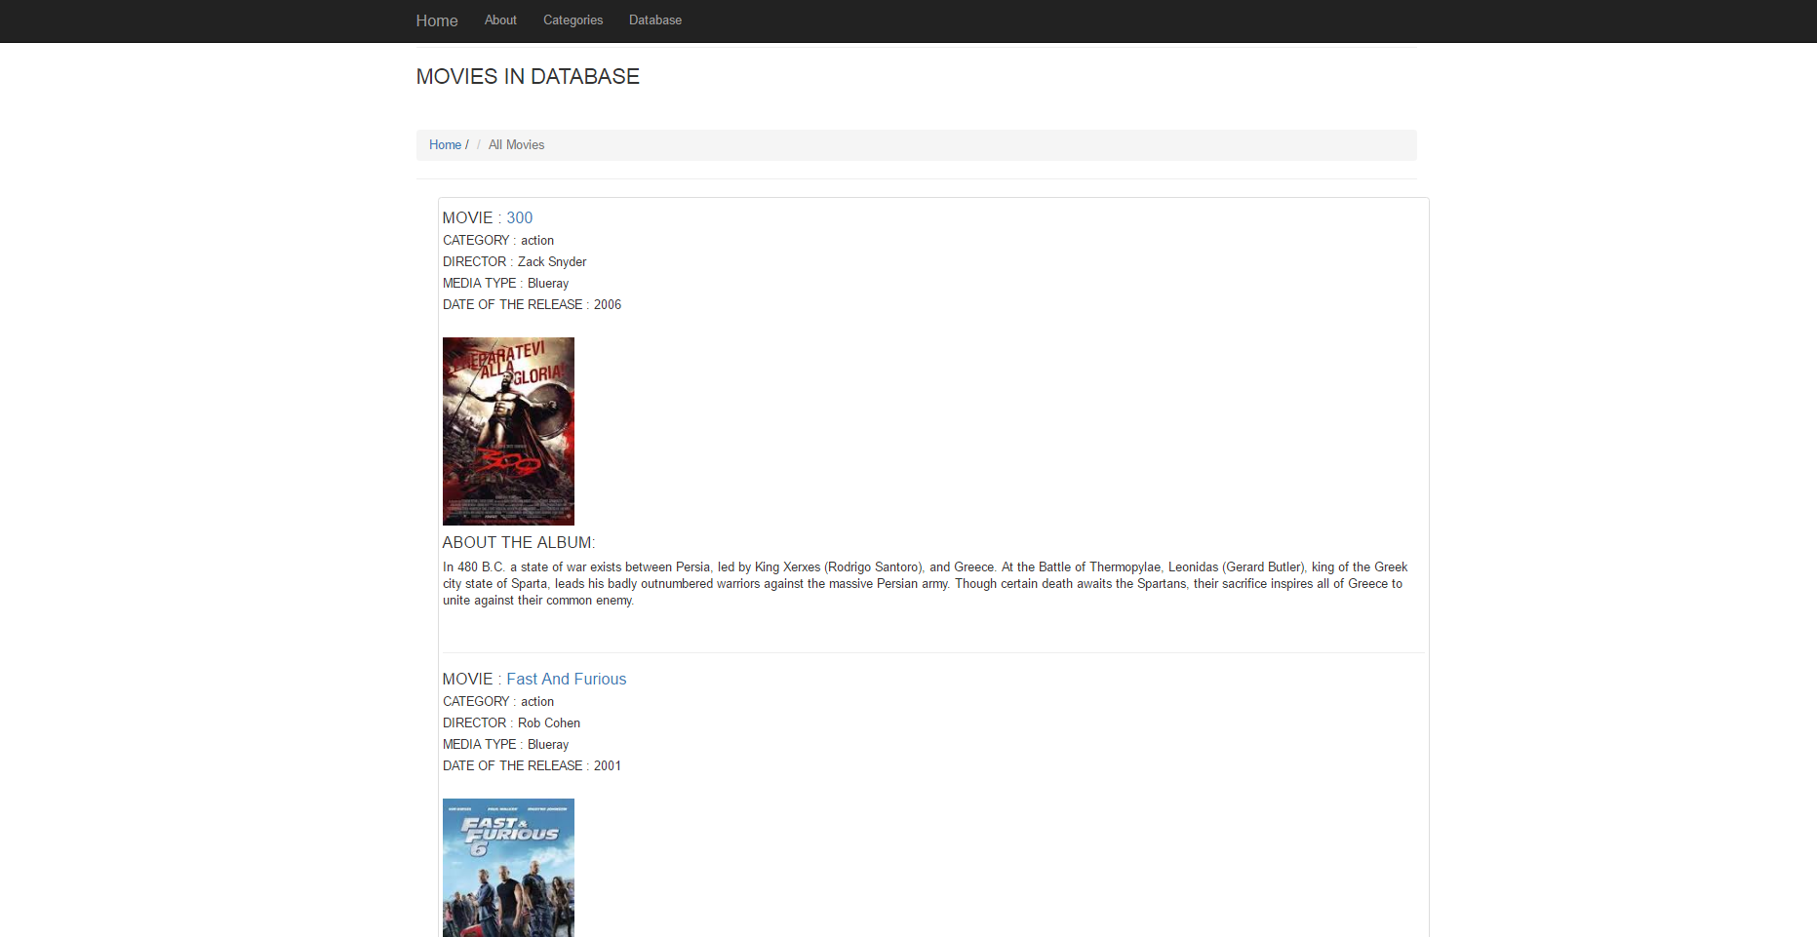

Single Movie Page

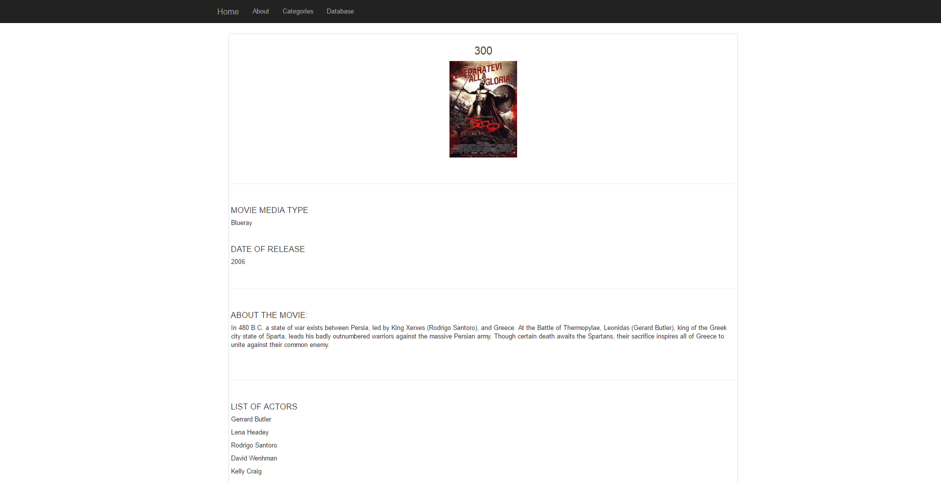

Redirecting to IMDb Website After Clicking on “Read More”

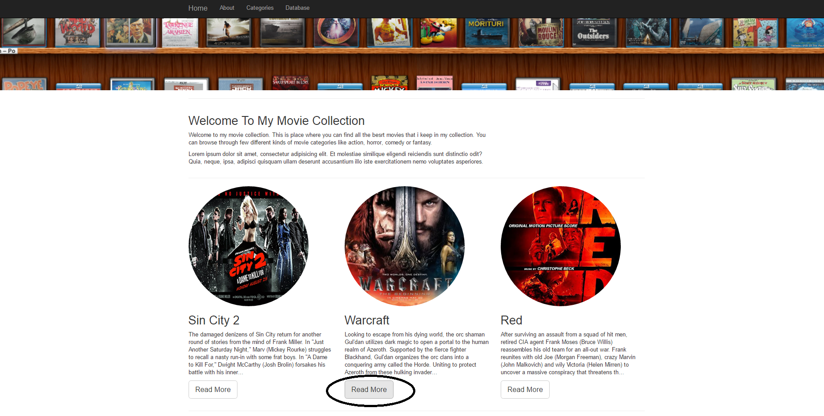

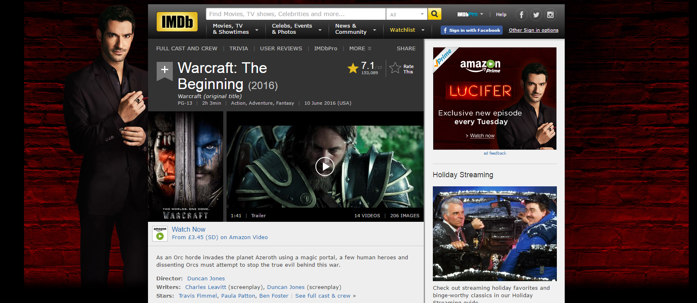

GitHub Repository (https://github.com/mati87118/MZMovie_Collection)

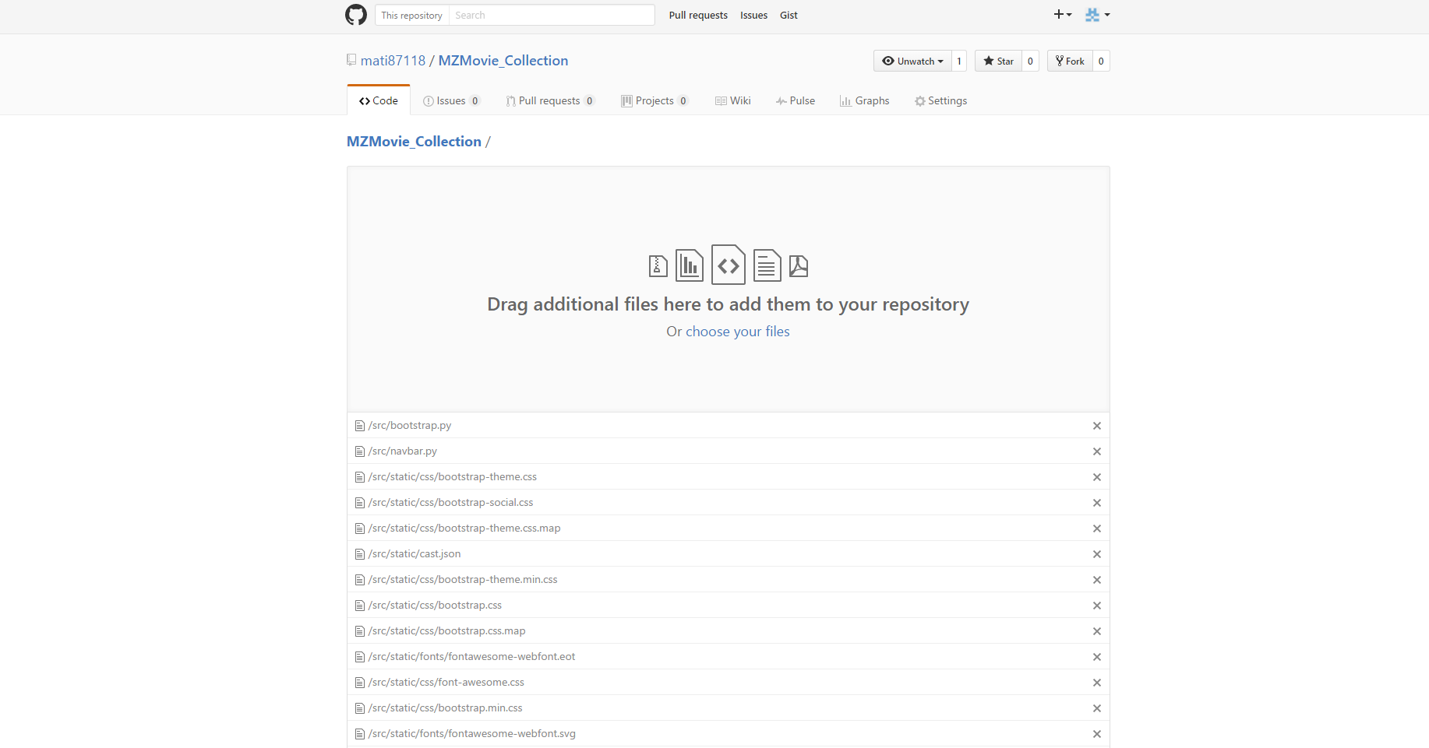

# References

* ***Course source code, Accessed 28 September 2016***

*https://github.com/siwells/teaching_set09103*

* ***Advanced Technologies Module website, Accessed 18 September 2016***

*http://siwells.github.io/teaching_set09103/*

* ***Flask Web Development with Python Tutorial – 1 -Basic App, Accessed 18 September 2016***

*https://www.youtube.com/watch?v=ZVGwqnjOKjk&list=PL6gx4Cwl9DGDi9F_slcQK7knjtO8TUvUs*

* ***Flask Tutorial Web Development with Python part 1 – 35, Accessed 18 – 22 September 2016***

*https://www.youtube.com/watch?v=Lv1fv-HmkQo&list=PLQVvvaa0QuDc_owjTbIY4rbgXOFkUYOUB*

* ***Flask Tutorial Web Development with Python Tutorial – 1 – 7, Accessed 23 September 2016***

*https://www.youtube.com/watch?v=ZVGwqnjOKjk&list=PL6gx4Cwl9DGDi9F_slcQK7knjtO8TUvUs*

* ***Learning Flask, Accessed 26 September 2016***

*https://www.lynda.com/Flask-tutorials/Learning-Flask/521231-2.html*

* ***Working with JSON in Python Flask, Accessed 1 October 2016***

*http://codehandbook.org/working-with-json-in-python-flask/*

# Resources

* ***300 Movie Cover image, Accessed 30 October 2016***

*https://www.google.co.uk/search?q=action+movies&rlz=1C1CHBF_en-GBGB711GB711&espv=2&biw=1920&bih=974&source=lnms&tbm=isch&sa=X&ved=0ahUKEwjwj7H7xI3QAhVECMAKHY0LBncQ_AUIBygC#tbm=isch&q=300+movie+covers&imgrc=BkpNTiGZiwPgnM%3A*

* ***Fast and Furious 6 Movie Cover image, Accessed 30 October 2016***

*https://www.google.co.uk/search?q=fast+and+furious+movie+covers&rlz=1C1CHBF_en-GBGB711GB711&espv=2&biw=1920&bih=974&tbm=isch&source=lnt&tbs=isz:ex,iszw:150,iszh:214#imgrc=7z38kb7ExPVonM%3A*

* ***Sin City 2 Movie Cover image, Accessed 30 October 2016***

*https://www.google.co.uk/search?q=fast+and+furious+movie+covers&rlz=1C1CHBF_en-GBGB711GB711&espv=2&biw=1920&bih=974&tbm=isch&source=lnt&tbs=isz:ex,iszw:150,iszh:214#tbs=isz:ex%2Ciszw:150%2Ciszh:214&tbm=isch&q=sin+city+2+movie+covers&imgrc=j_tMxRBgRiaUeM%3A*

* ***Avengers Sin City 2 Movie Cover image, Accessed 30 October 2016***

*https://www.google.co.uk/search?q=fast+and+furious+movie+covers&rlz=1C1CHBF_en-GBGB711GB711&espv=2&biw=1920&bih=974&tbm=isch&source=lnt&tbs=isz:ex,iszw:150,iszh:214#tbs=isz:ex%2Ciszw:150%2Ciszh:214&tbm=isch&q=avengers+movie+covers&imgrc=d4boK3uKNCPRBM%3A*

* ***Ted Movie Cover image, Accessed 30 October 2016***

*https://www.google.co.uk/search?q=fast+and+furious+movie+covers&rlz=1C1CHBF_en-GBGB711GB711&espv=2&biw=1920&bih=974&tbm=isch&source=lnt&tbs=isz:ex,iszw:150,iszh:214#tbs=isz:ex%2Ciszw:150%2Ciszh:214&tbm=isch&q=ted+movie+covers&imgrc=iVnJ5cfanucYgM%3A*

* ***Hangover Movie Cover image, Accessed 30 October 2016***

*https://www.google.co.uk/search?q=fast+and+furious+movie+covers&rlz=1C1CHBF_en-GBGB711GB711&espv=2&biw=1920&bih=974&tbm=isch&source=lnt&tbs=isz:ex,iszw:150,iszh:214#tbs=isz:ex%2Ciszw:150%2Ciszh:214&tbm=isch&q=hangover+movie+covers&imgrc=V7Jy0dSC-UYJpM%3A*

* ***Hall Pass Movie Cover image, Accessed 30 October 2016***

*https://www.google.co.uk/search?q=fast+and+furious+movie+covers&rlz=1C1CHBF_en-GBGB711GB711&espv=2&biw=1920&bih=974&tbm=isch&source=lnt&tbs=isz:ex,iszw:150,iszh:214#tbs=isz:ex%2Ciszw:150%2Ciszh:214&tbm=isch&q=hall+pass+movie+covers&imgdii=i8QbEruedGteIM%3A%3Bi8QbEruedGteIM%3A%3BRyKrbUkhHjy6UM%3A&imgrc=i8QbEruedGteIM%3A*

* ***The Ugly Truth Movie Cover image, Accessed 30 October 2016***

*https://www.google.co.uk/search?q=fast+and+furious+movie+covers&rlz=1C1CHBF_en-GBGB711GB711&espv=2&biw=1920&bih=974&tbm=isch&source=lnt&tbs=isz:ex,iszw:150,iszh:214#q=the+ugly+truth+movie+covers&tbm=isch&tbas=0&imgrc=nhTkMs5bywl-dM%3A*

* ***Into the Woods Movie Cover image, Accessed 30 October 2016***

*https://www.google.co.uk/search?q=the+ugly+truth+movie+covers&rlz=1C1CHBF_en-GBGB711GB711&espv=2&biw=1920&bih=974&tbas=0&tbm=isch&source=lnt&tbs=isz:ex,iszw:150,iszh:214#q=into+the+woods+movie+covers&tbs=iszw:150,iszh:214,isz:m&tbm=isch&imgrc=tvQ5wlrW3JUIdM%3A*

* ***The Guardians of The Galaxy Movie Cover image, Accessed 30 October 2016*** *https://www.google.co.uk/search?q=the+ugly+truth+movie+covers&rlz=1C1CHBF_en-GBGB711GB711&espv=2&biw=1920&bih=974&tbas=0&tbm=isch&source=lnt&tbs=isz:ex,iszw:150,iszh:214#tbs=iszw:150%2Ciszh:214%2Cisz:m&tbm=isch&q=guardians+of+the+galaxy+movie+covers&imgrc=JSHPlsnAVC92WM%3A*
* ***Maleficent Movie Cover image, Accessed 30 October 2016***

*https://www.google.co.uk/search?q=the+ugly+truth+movie+covers&rlz=1C1CHBF_en-GBGB711GB711&espv=2&biw=1920&bih=974&tbas=0&tbm=isch&source=lnt&tbs=isz:ex,iszw:150,iszh:214#tbs=iszw:150%2Ciszh:214%2Cisz:m&tbm=isch&q=maleficent+movie+covers&imgrc=MMCbuK2W7ZXqeM%3A*

* ***Hobbit Movie Cover image, Accessed 30 October 2016***

*https://www.google.co.uk/search?q=the+ugly+truth+movie+covers&rlz=1C1CHBF_en-GBGB711GB711&espv=2&biw=1920&bih=974&tbas=0&tbm=isch&source=lnt&tbs=isz:ex,iszw:150,iszh:214#tbs=iszw:150%2Ciszh:214%2Cisz:m&tbm=isch&q=hobbit+movie+covers&imgrc=GopKRCRA10qixM%3A*

* ***Fright Night Movie Cover image, Accessed 30 October 2016***

*https://www.google.co.uk/search?q=fright+night+movie+covers&rlz=1C1CHBF_en-GBGB711GB711&espv=2&biw=1920&bih=974&tbs=isz:ex,iszw:150,iszh:214&tbm=isch&source=lnt#imgrc=xzlwPSubMa6sMM%3A*

* ***Nightmare on the Elm Street Movie Cover image, Accessed 30 October 2016***

*https://www.google.co.uk/search?q=fright+night+movie+covers&rlz=1C1CHBF_en-GBGB711GB711&espv=2&biw=1920&bih=974&tbs=isz:ex,iszw:150,iszh:214&tbm=isch&source=lnt#tbs=isz:ex,iszw:150,iszh:214&tbm=isch&q=nightmare+on+the+elm+street+movie+covers&imgrc=7rdAUj45Rl3XgM%3A*

* ***The Ring Movie Cover image, Accessed 30 October 2016***

*https://www.google.co.uk/search?q=fright+night+movie+covers&rlz=1C1CHBF_en-GBGB711GB711&espv=2&biw=1920&bih=974&tbs=isz:ex,iszw:150,iszh:214&tbm=isch&source=lnt#tbs=isz:ex%2Ciszw:150%2Ciszh:214&tbm=isch&q=the+ring+movie+covers&imgrc=DCr67ITUR100TM%3A*

* ***IT Movie Cover image, Accessed 30 October 2016***

https://www.google.co.uk/search?q=fright+night+movie+covers&rlz=1C1CHBF_en-GBGB711GB711&espv=2&biw=1920&bih=974&tbs=isz:ex,iszw:150,iszh:214&tbm=isch&source=lnt#tbs=iszw:150%2Ciszh:214%2Cisz:m&tbm=isch&q=it+the+movie+cover&imgrc=OuDQlomABTNnxM%3A

* ***Warcraft Movie Cover image, Accessed 30 October 2016***

*https://www.google.co.uk/search?q=warc+movie+cover&rlz=1C1CHBF_en-GBGB711GB711&espv=2&biw=1920&bih=974&tbs=isz:ex,iszw:150,iszh:214&tbm=isch&source=lnt#tbs=isz:ex%2Ciszw:150%2Ciszh:214&tbm=isch&q=warcraft+movie+cover&imgrc=_uhc0LFxIG0yJM%3A*

* ***Red Cover image, Accessed 30 October 2016***

*https://www.google.co.uk/search?q=warc+movie+cover&rlz=1C1CHBF_en-GBGB711GB711&espv=2&biw=1920&bih=974&tbs=isz:ex,iszw:150,iszh:214&tbm=isch&source=lnt#q=red+movie+cover&tbs=iszw:150,iszh:214,isz:m&tbm=isch&imgrc=E2OuI5jtIWEFzM%3A*